# CO2

Homework 3, Smoothing

Methods of Applied Statistics Due

Figure 1 shows atmoshperic Carbon Dioxide concentrations from an observatory in Haiwaii, made available by the Scripps CO Program at [scrippsco2.ucsd.edu](http://scrippsco2.ucsd.edu/). The figure was produced with code in the appendix.

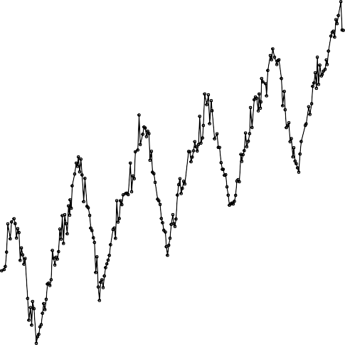

380

400

420

410

415

ϵ

|  |  |  |  |  |  |  |  |  |  |  |
| --- | --- | --- | --- | --- | --- | --- | --- | --- | --- | --- |
| 1960 | 1970 | 1980 1990 2000 | 2010 | 2020 | 2015 | 2016 | 2017 | 2018 | 2019 | 2020 |
|  |  | time |  |  |  |  |  | time |  |  |

* 1. all

320

340

400

405

* 1. recent

Figure 1: CO2 at Mauna Loa Observatory, Hawaii

ppm 360

ppm

Write a short consulting report (roughly a page of writing) discussing if the CO2 data appears to be impacted by the following events:

* the fall of the Berlin wall in November 1989 years ago, preceding a dramatic fall in industrial production in the Soviet Union and Eastern Europe;
* the global lockdown during the COVID-19 pandemic starting in February 2020, shutting down much of the global economy.

You should

* explain fully the model you are using and why you have chosen to use it
* make your graphs look nice
* at a minimum, plot the estimated smoothed trend of CO2 and discuss whether it appears shallower or steeper after the events listed above.
* visual investigation is sufficient, you aren’t expected for formally test for effects.

# Death

Daily mortality counts in Quebec is available from [www.stat.gouv.qc.ca/statistiques/population-](https://www.stat.gouv.qc.ca/statistiques/population-demographie/deces-mortalite/nombre-hebdomadaire-deces_an.html) [demographie/deces-mortalite/nombre-hebdomadaire-deces_an.html](https://www.stat.gouv.qc.ca/statistiques/population-demographie/deces-mortalite/nombre-hebdomadaire-deces_an.html)

An imaginary government official believes that the first wave of the COVID-19 epidemic, in March, April and May, primarily affected the elderly. The second wave, which began in September, is caused by irresponsible young people, primarily university undergraduates, acting irresponsibly. Evidence of this can be seen in the weekly mortality counts. Deaths amongst the elderly in the spring were well above the historical averages, whereas the under 50’s had deaths in line with previous years. In the most recent death data, there is an increase in deaths in the under 50’s whereas the over 70’s have no more deaths than would be expected pre-covid.

Your task is to write a report explaining whether or not the mortality data support the above hypotheses. The code below calculates total excess mortality in the spring and the fall. You will probably find it useful to repeat the analysis twice, once for 70+ and once for <50.

Write a short report (2 pages of text, plus figures and tables).

* Make your report self-contained, so it can be understood by someone who has not seen the assignment sheet.
* You are expected to use Bayesian inference and some sort of semi-parametric time trend, because that’s what this assignment is evaluating you on. However, you’re free to use different software or a different model if you’d like.
* clearly explain the statistical model you’ve used with equations, and state your prior distributions. Explain how your priors are reasonable.
* consider plotting quantiles in place of the posterior samples I’ve plotted
* make your figures and tables look nice and properly captioned.

# Appendix

## CO2

cUrl = paste0(["http://scrippsco2.ucsd.edu/assets/data/atmospheric/"](http://scrippsco2.ucsd.edu/assets/data/atmospheric/), "stations/flask_co2/daily/daily_flask_co2_mlo.csv")

cFile = basename(cUrl)

**if** (!file.exists(cFile)) download.file(cUrl, cFile) co2s = read.table(cFile, header = FALSE, sep = ",",

skip = 69, stringsAsFactors = FALSE, col.names = c("day", "time", "junk1", "junk2", "Nflasks", "quality", "co2"))

co2s$date = strptime(paste(co2s$day, co2s$time), format = " Y- m- d H: M", tz = "UTC")

*# remove low-quality measurements*

co2s = co2s[co2s$quality == 0, ]

plot(co2s$date, co2s$co2, log = "y", cex = 0.3, col = "#00000040", xlab = "time", ylab = "ppm")

plot(co2s[co2s$date > ISOdate(2015, 3, 1, tz = "UTC"), c("date", "co2")], log = "y", type = "o", xlab = "time", ylab = "ppm", cex = 0.5)

The code below might prove useful.

co2s$day = as.Date(co2s$date)

toAdd = data.frame(day = seq(max(co2s$day) + 3, as.Date("2025/1/1"), by = "10 days"), co2 = NA)

co2ext = rbind(co2s[, colnames(toAdd)], toAdd) timeOrigin = as.Date("2000/1/1")

co2ext$timeInla = round(as.numeric(co2ext$day - timeOrigin)/365.25, 2)

co2ext$cos12 = cos(2 * pi * co2ext$timeInla) co2ext$sin12 = sin(2 * pi * co2ext$timeInla) co2ext$cos6 = cos(2 * 2 * pi * co2ext$timeInla) co2ext$sin6 = sin(2 * 2 * pi * co2ext$timeInla)

library('INLA', verbose=FALSE)

*# disable some error checking in INLA*

mm = get("inla.models", INLA:::inla.get.inlaEnv()) **if**(class(mm) == 'function') mm = mm() mm$latent$rw2$min.diff = NULL

assign("inla.models", mm, INLA:::inla.get.inlaEnv())

co2res = inla(co2 ~ sin12 + cos12 + sin6 + cos6 + f(timeInla, model = 'rw2',

prior='pc.prec', param = c(0.1, 0.5)), data = co2ext, family='gamma', control.family = list(hyper=list(prec=list(

prior='pc.prec', param=c(0.1, 0.5)))),

*# add this line if your computer has trouble # control.inla = list(strategy='gaussian'),*

control.predictor = list(compute=TRUE, link=1), control.compute = list(config=TRUE), verbose=FALSE)

qCols = c('0.5quant','0.025quant','0.975quant') Pmisc::priorPost(co2res)$summary[,qCols]

0.5quant 0.025quant 0.975quant sd for gamma 2.89227e-06 2.831783e-06 2.941706e-06

sd for timeInla 2.67051e-03 2.546393e-03 2.749882e-03

*# source('https://bioconductor.org/biocLite.R') # biocLite('Biobase')*

sampleList = INLA::inla.posterior.sample(30, co2res, selection = list(timeInla = 0))

sampleMean = do.call(cbind, Biobase::subListExtract(sampleList, "latent"))

sampleDeriv = apply(sampleMean, 2, diff)/diff(co2res$summary.random$timeInla$ID)

matplot(co2ext$day, co2res$summary.fitted.values[, qCols], type = "l", col = "black", lty = c(1, 2, 2), log = "y", xlab = "time", ylab = "ppm")

Stime = timeOrigin + round(365.25 * co2res$summary.random$timeInla$ID) matplot(Stime, co2res$summary.random$timeInla[, qCols],

type = "l", col = "black", lty = c(1, 2, 2), xlab = "time", ylab = "y")

matplot(Stime[-1], sampleDeriv, type = "l", lty = 1,

xaxs = "i", col = "#00000020", xlab = "time", ylab = "deriv", ylim = quantile(sampleDeriv, c(0.01, 0.995)))

forX = as.Date(c("2018/1/1", "2021/1/1")) forX = seq(forX[1], forX[2], by = "6 months")

toPlot = which(Stime > min(forX) & Stime < max(forX))

matplot(Stime[toPlot], sampleDeriv[toPlot, ], type = "l", lty = 1, lwd = 2, xaxs = "i", col = "#00000050",

xlab = "time", ylab = "deriv", xaxt = "n", ylim = quantile(sampleDeriv[toPlot,

], c(0.01, 0.995)))

axis(1, as.numeric(forX), format(forX, " b Y"))

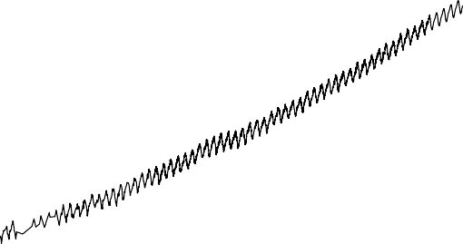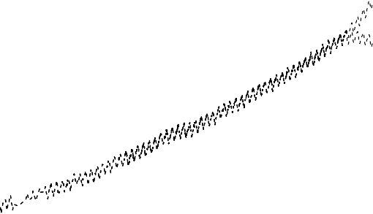

ppm

360 380

400

420

440

y

−0.15 −0.10 −0.05 0.00 0.05 0.10 0.15

|  |  |  |  |  |  |  |  |  |  |  |  |  |  |
| --- | --- | --- | --- | --- | --- | --- | --- | --- | --- | --- | --- | --- | --- |
| 1960 | 1970 | 1980 | 1990 | 2000 | 2010 | 2020 | 1960 | 1970 | 1980 | 1990 | 2000 | 2010 | 2020 |
|  |  |  | time |  |  |  |  |  |  | time |  |  |  |

* 1. predicted (b) random effect

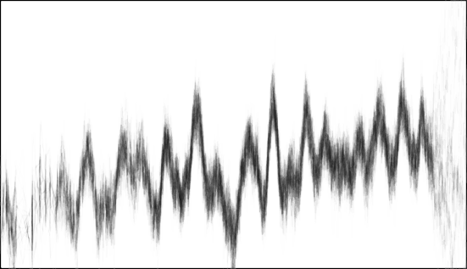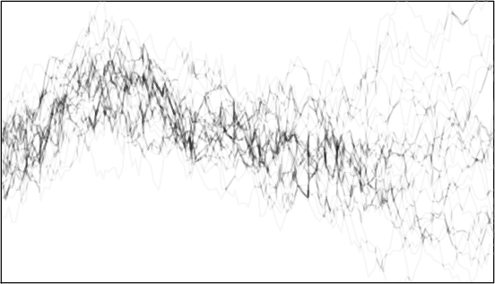

deriv

0.006 0.008

0.010

0.012

320

340

deriv 0.006

0.008

1970 1980 1990 2000 2010 2020

0.000

0.002

0.004

time

1. derivative

Jul2018 Jan2019 Jul2019 Jan2020 Jul2020

0.002

0.004

time

1. derivative, detail

Figure 2: INLA results

## Covid

Download some data

xWide = read.table(paste0(["https://www.stat.gouv.qc.ca/statistiques/"](http://www.stat.gouv.qc.ca/statistiques/),

"population-demographie/deces-mortalite/", "WeeklyDeaths_QC_2010-2020_AgeGr.csv"), sep = ";", skip = 7, col.names = c("year", "junk",

"age", paste0("w", 1:53)))

xWide = xWide[grep("^[[:digit:]]+$", xWide$year), ] x = reshape2::melt(xWide, id.vars = c("year", "age"),

measure.vars = grep("^w[[:digit:]]+$", colnames(xWide))) x$dead = as.numeric(gsub("[[:space:]]", "", x$value)) x$week = as.numeric(gsub("w", "", x$variable))

x$year = as.numeric(x$year)

x = x[order(x$year, x$week, x$age), ]

convert the ‘week’ variable to time

newYearsDay = as.Date(ISOdate(x$year, 1, 1)) x$time = newYearsDay + 7 * (x$week - 1)

x = x[!is.na(x$dead), ] x = x[x$week < 53, ]

Plot two different ways

plot(x[x$age == "Total", c("time", "dead")], type = "o", log = "y")

1600

1800 2000

2010 2012 2014 2016 2018 2020

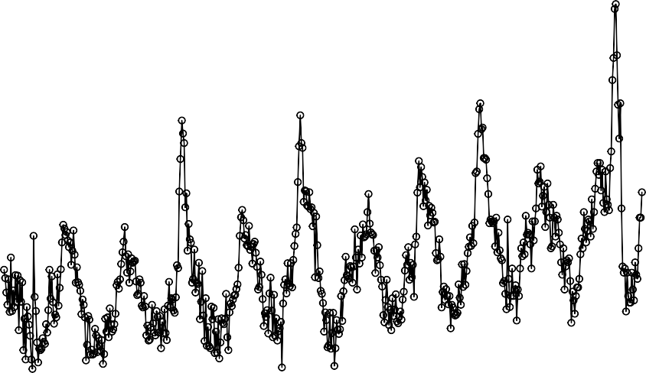

dead 1400

1000

1200

time

Figure 3

xWide2 = reshape2::dcast(x, week + age ~ year, value.var = "dead") Syear = grep("[[:digit:]]", colnames(xWide2), value = TRUE)

Scol = RColorBrewer::brewer.pal(length(Syear), "Spectral") matplot(xWide2[xWide2$age == "Total", Syear], type = "l",

lty = 1, col = Scol)

legend("topright", col = Scol, legend = Syear, bty = "n", lty = 1, lwd = 3)

1600

1800

2000

0 10 20 30 40 50

2010

2011

2012

2013

2014

2015

2016

2017

2018

2019

2020

xWide2[xWide2$age == "Total", Syear]

1000

1200

1400

Figure 4

Divide the data into pre and post covid, add extra dates to data so that INLA will create forecasts.

dateCutoff = as.Date("2020/3/1") xPreCovid = x[x$time < dateCutoff, ] xPostCovid = x[x$time >= dateCutoff, ]

toForecast = expand.grid(age = unique(x$age), time = unique(xPostCovid$time), dead = NA)

xForInla = rbind(xPreCovid[, colnames(toForecast)], toForecast)

xForInla = xForInla[order(xForInla$time, xForInla$age),

]

Create some time variables, including sines and cosines. Time in years and centred is numerically stable in INLA.

xForInla$timeNumeric = as.numeric(xForInla$time)

xForInla$timeForInla = (xForInla$timeNumeric - as.numeric(as.Date("2015/1/1")))/365.25 xForInla$timeIid = xForInla$timeNumeric

xForInla$sin12 = sin(2 * pi * xForInla$timeNumeric/365.25) xForInla$sin6 = sin(2 * pi * xForInla$timeNumeric *

2/365.25)

xForInla$cos12 = cos(2 * pi * xForInla$timeNumeric/365.25) xForInla$cos6 = cos(2 * pi * xForInla$timeNumeric *

2/365.25)

fit a model for total deaths in INLA

xForInlaTotal= xForInla[xForInla$age == 'Total', ] library(INLA, verbose=FALSE)

Loading required package: Matrix Loading required package: sp Loading required package: parallel Loading required package: foreach

This is INLA_20.08.11-1 built 2020-08-11 09:32:13 UTC.

* See [www.r-inla.org/contact-us](http://www.r-inla.org/contact-us) for how to get help.
* To enable PARDISO sparse library; see inla.pardiso()
* Save 425.1Mb of storage running 'inla.prune()'

res = inla(dead ~ sin12 + sin6 + cos12 + cos6 + f(timeIid, prior='pc.prec', param= c(log(1.2), 0.5)) +

f(timeForInla, model = 'rw2', prior='pc.prec', param= c(0.01, 0.5)), data=xForInlaTotal,

control.predictor = list(compute=TRUE, link=1), control.compute = list(config=TRUE),

*# control.inla = list(fast=FALSE, strategy='laplace'),*

family='poisson')

parameters

qCols = paste0(c(0.5, 0.025, 0.975), "quant") rbind(res$summary.fixed[, qCols], Pmisc::priorPostSd(res)$summary[,

qCols])

0.5quant 0.025quant 0.975quant (Intercept) 7.10132633 7.095135708 7.10730664

sin12 0.05140121 0.044891417 0.05796350

SD for timeForInla 0.13827167 0.089468447 0.21211178

|  |  |
| --- | --- |
| sin6 | 0.01127193 0.005632171 0.01690051 |
| cos12 | 0.09736361 0.090828734 0.10395743 |
| cos6 | 0.01302345 0.007378958 0.01865081 |
| SD for timeIid | 0.03564929 0.032055718 0.03955956 |

Plot predicted intensity and random effect

matplot(xForInlaTotal$time, res$summary.fitted.values[, qCols], type = "l", ylim = c(1000, 1800), lty = c(1, 2, 2), col = "black", log = "y")

points(x[x$age == "Total", c("time", "dead")], cex = 0.4, col = "red")

1400

1600

1800

2010 2012 2014 2016 2018 2020

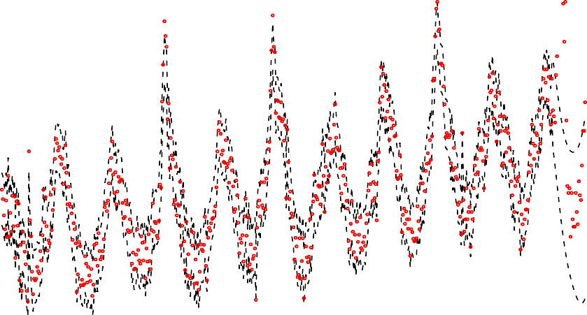

res$summary.fitted.values[, qCols]

1000

1200

xForInlaTotal$time

Figure 5

matplot(xForInlaTotal$time, res$summary.random$timeForInla[, c("0.5quant", "0.975quant", "0.025quant")], type = "l", lty = c(1, 2, 2), col = "black", ylim = c(-1, 1) *

0.1)

Take posterior samples of the intensity

sampleList = INLA::inla.posterior.sample(30, res, selection = list(Predictor = 0)) sampleIntensity = exp(do.call(cbind, Biobase::subListExtract(sampleList,

"latent")))

sampleDeaths = matrix(rpois(length(sampleIntensity), sampleIntensity), nrow(sampleIntensity), ncol(sampleIntensity))

plot samples and real data

matplot(xForInlaTotal$time, sampleDeaths, col = "#00000010", lwd = 2, lty = 1, type = "l", log = "y")

points(x[x$age == "Total", c("time", "dead")], col = "red", cex = 0.5)

matplot(xForInlaTotal$time, sampleDeaths, col = "#00000010",

lwd = 2, lty = 1, type = "l", log = "y", xlim = as.Date(c("2019/6/1", "2020/11/1")), ylim = c(1, 2.3) * 1000)

1400

1600

0.05

0.10

2010 2012 2014 2016 2018 2020

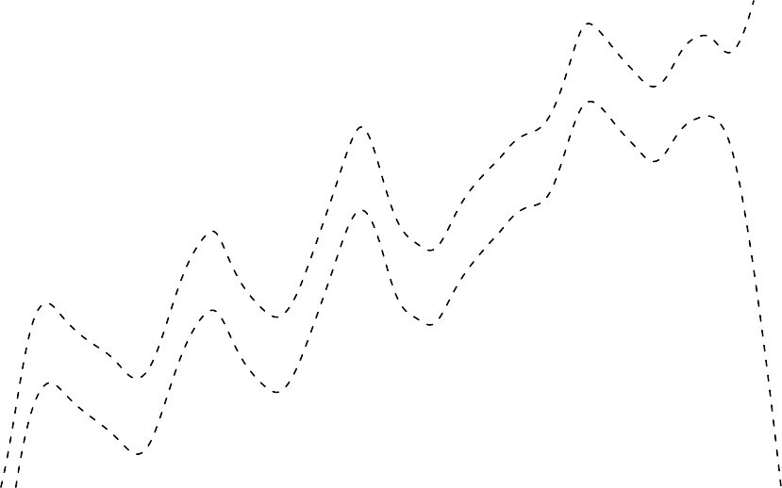

es$summary.random$timeForInla[, c("0.5quant", "0.975quant", "0.025

−0.10

−0.05

0.00

xForInlaTotal$time

Figure 6

2010 2012 2014 2016 2018 2020

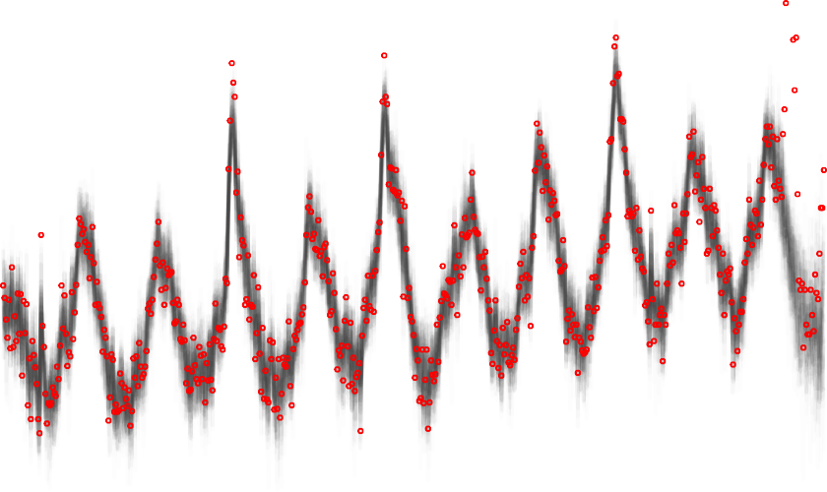

sampleDeaths

1000

1200

xForInlaTotal$time

Figure 7

points(x[x$age == "Total", c("time", "dead")], col = "red", cex = 0.5)

1600 1800 2000

2020

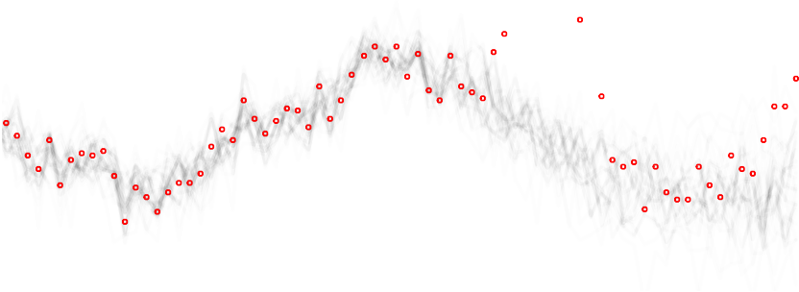

sampleDeaths

1000

1200

1400

xForInlaTotal$time

Figure 8

calculate excess deaths

xPostCovidTotal = xPostCovid[xPostCovid$age == "Total",

]

xPostCovidForecast = sampleDeaths[match(xPostCovidTotal$time, xForInlaTotal$time), ]

excessDeaths = xPostCovidTotal$dead - xPostCovidForecast

plot samples of excess deaths

matplot(xPostCovidTotal$time, xPostCovidForecast, type = "l", ylim = c(1000, 2200), col = "black")

points(xPostCovidTotal[, c("time", "dead")], col = "red")

matplot(xPostCovidTotal$time, excessDeaths, type = "l", lty = 1, col = "#00000030")

Total excess deaths march-may inclusive

excessDeathsSub = excessDeaths[xPostCovidTotal$time > as.Date("2020/03/01") & xPostCovidTotal$time < as.Date("2020/06/01"), ]

excessDeathsInPeriod = apply(excessDeathsSub, 2, sum) round(quantile(excessDeathsInPeriod))

0 25 50 75 100

4098 4568 4727 5071 5859

Excess deaths in most recent week

round(quantile(excessDeaths[nrow(excessDeaths), ])) 0 25 50 75 100

84 158 230 289 443

600

800

1800

2000

2200

Mar May Jul Sep xPostCovidTotal$time

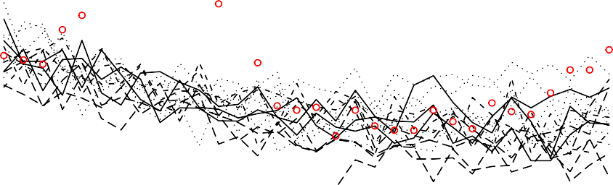

xPostCovidForecast

1000

1200

1400

1600

Figure 9

Mar May Jul Sep xPostCovidTotal$time

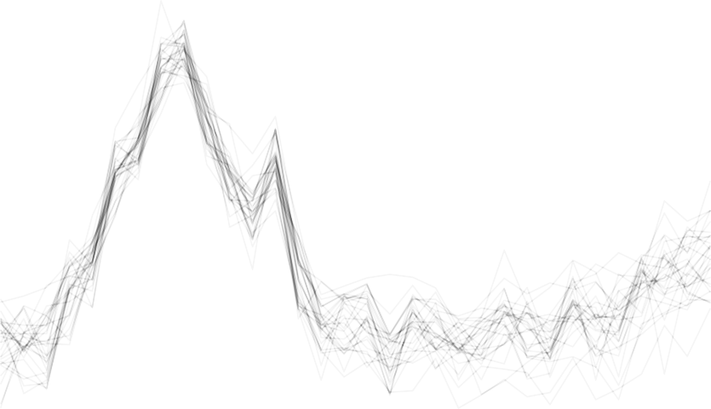

excessDeaths 400

−200

0

200

Figure 10